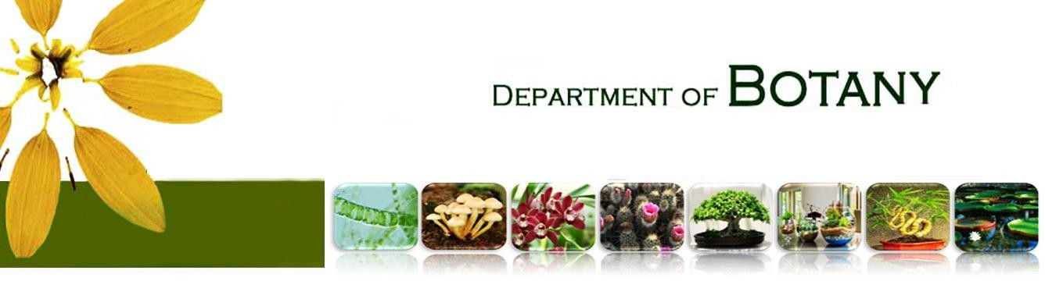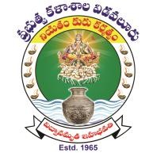

In view of lively rural surroundings and rich diversity in plants and bio- culture, there has been a candid demand for opening of Department of Botany in PRR & VS Government College. Hence the Departments of Botany was opened in the college during 1965 and completed 50 years in 2015. It has been enrolled for general stream of B. Sc (BZC) and offering a three years Bachelor of Science Degree. Botany department is one of the major departments in our college. The department is committed to the development of academic excellence in teaching. The department is highly motivated and excited to share both their knowledge and passion in the field of Botany. As an integral part of the undergraduate education, the department carries out extensive field work to ensure that our undergraduate programme is at par with the current requirements in Botany practical field. The Department is providing Departmental library facility with a number of reference books to support the needy students. The department is organising the university level seminars college level seminars, seminars on environmental issues, awareness programmes science exhibitions, research and various social service activities. The department is planning to organize National Conferences and workshops to inculcate research and competition culture among the faculty and students. Keeping pace with the advanced knowledge, the Department updates the curriculum from time to time and has introduced the Choice Based Credit System.


The aim of the Department is to strengthen its core activities of teaching, training and research. The department would also like to expand in future, the development of technology and industrial interaction under its auspices. The main thrust of the Department however is in the areas like Taxonomy of Angiosperm, Morphology, Anatomy, Wood analysis, Phytogeography, Pharmacognosy, Phytochemistry, Ethnobotany, Ecology, Phycology, Mycology, Bryology, Pteridology, physiology, cell Biology, Biotechnology, Molecular Biology, Genetics, Plant Breeding, Horticulture and conservation of Bio- diversity. The main aim of the Department is the academic, Educational and financial progress in Students by providing proper Education, Guidance and Skills.

Vision of the Department:
- To maintain a harmonious relationship with the students.
- To motivate students to reach frontiers of biological sciences.
- To develop research aptitude and scientific temperament.
- To create most conducive environment to the students that they would fore-cost the ultimate goals of their studies in future.
- To make students hard working and inculcate innovation and creativity.
- To acquire knowledge on the role of plants in ecosystem and its relationship to animals, man and to maintain ecological balance.
- To prepare students towards Self- Employment by teaching Self- Sustainable Skills and Laboratory Techniques.
- To nurse a Botanical Garden in the department for the benefit of the students for a practical assessment of Botanical inventory, which would create an experimental process.

Mission:
- To make students aware of the need for taking in to consideration of Global Warming and Climate change.
- To provide awareness to the students on career completion and research aptitude.
- To achieve value-oriented and fact-finding results.
- To create environment for research studies in a particular subject of student’s choice
- To expand the frontiers of knowledge to serve the society.
- To organize conferences and seminars on current Ecological problems that will be of benefit to the community.

- To build confidence and enhance opportunities to the rural students for their successful career.
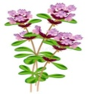
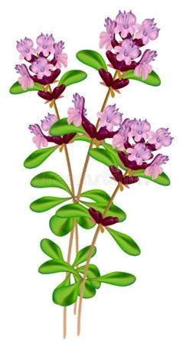

COURSES OFFERED:
Bachelor of Science (B.Sc.) in Botany Certificate Courses
Add-on Courses DURATION:
B.Sc. : 3 Years
Certificate Courses : 3Months
Add-on Courses : 3 Month
s

ELIGIBILITY:
- B.Sc. (B. Z. C)

Passed with 50% aggregate marks (35% marks in case of candidate belonging to SC/ST) in Intermediate (10+2) examination or equivalent with English, Physics, Chemistry and Botany & Zoology (Biology).
Medium of Instruction: English/Telugu

Department Highlights:
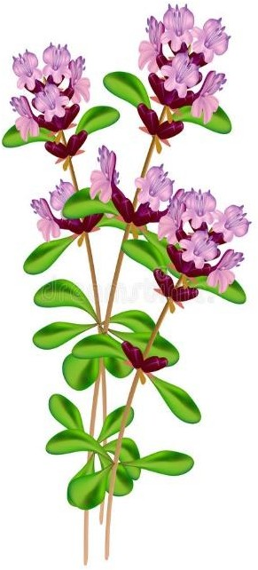
- Since the initiation of the department, various educational trips have been organized for familiarizing the students with different plant species in their natural environment.
- Staff of the Department are acting as the co-ordinators of various college committees like, NSS, Eco club, Antiaging, Hostel, Discipline, Biometrics, Literary & cultural etc. and extending their hands whole heartedly for the smooth functioning of college activities
- Students of the department Regularly focus on the development and maintenance botanical garden, maintenance museum of the department Clean and green in the campus, Plantation in the Campus.
- Different events are conducted by the department to enhance the awareness of the students regarding environmental issues like No plastic, Ozone Day, AID awareness rally, Water conservation etc...
- The Department Celebrates the International Women’s Day, Darwin’s Day,
Science Day etc.
- The Department Organises the different departmental events like fresher’s day, welcome and farewell programmes.
- The Department organises the plantation drives in the College Campus periodically

  - The Department conducts the workshops and expert lectures on topics like mushroom cultivation, maintenance of plant samples, importance of clean energy sources, etc.
  - The Department is maintaining an Herbal Garden with more than 52 live plant species of medicinal, aesthetic, economic and rare plants mostly for educational purposes.
  - Department has a museum having a collection of more than 105 species in herbarium, some preserved samples and seed samples.
  - Department is maintaining a botanical garden in the college premises which is mainly concerned with the preservation of plants and education of the students of the college.
  - The students of the department are good in their academics and they are getting 100% result in the university examination.
  - The department is providing guidance and coaching for the academic progression of the students
  - The department is encouraging the students to participate in the NSS,
NCC, Sports, Literary and cultural activities etc…
  - Department is collecting funds voluntarily and donating them to the needy students
  - Department is participating in several social service activities by conducting and participating in rallies of social awareness like ODF rally, Swatch Bharath rally etc…
  - The students are getting seats in the central universities and state universities and they are continuing their further education without fail till they get the self-sufficiency.

Number of teaching posts sanctioned: Lecturers: 2

Faculty(Worked/ Working) :
Smt. Lalithamba (Rtd)
Dr. Suresh (Rtd)
Dr. Umashankar Raju
Smt. Ramadevi
Smt. Audiseshamma(Rtd) ,,; Sri. JohnPaul
Sri. K. Ravichandra Reddy (working)
Sri. P. Sudhakar (working)
YouTube Channel:



https://www.youtube.com/cha nnel/UCgSJJRL2fwI6Y_7PlrfTkUA

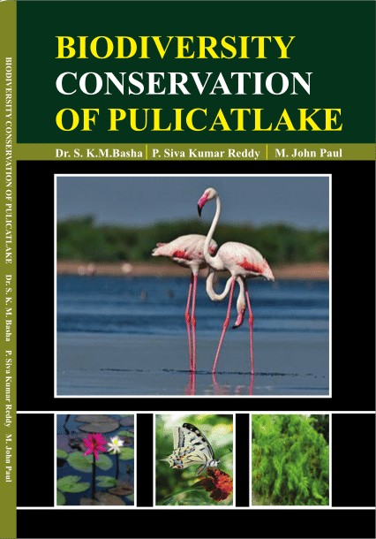
Books Published: AVAILABLE ON: HTPPS// WWW.AMAZON.IN

- Biodiversity Conservation of Pulicatlake SARA Book Publications
ISBN: 978-1-63041-922-6

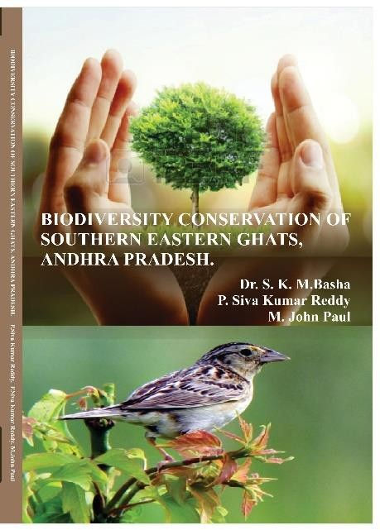

Biodiversity Conservation of Southern Eastern Ghats, A. P SARA Book Publications
ISBN: 978-1-73040-617-1
Important Publications Available in the Department:
Antimicrobial profile of crude extracts Calotropis procera and Centella asiatica against some important pathogens Indian Journal of Science and Technology
ISSN: 0974-6846
Antioxidant Activities of Marine Algae: A Review International Journal of Resent Scientific Research ISSN: 0976-3031
Political Resurgence and Gandhism in Raja Rao’s Short Stories
Emerging Trends in English Conference Proceedings
Ethanomedicinal uses of some plant species of Velugonda Hill Range, Eastern Ghats, Andhra Pradesh Journal of Economic botany and Taxonomy
ISSN: 2050-9768
Ethanobotanical study of Talakona, Eastern Ghats, Andhra Pradesh The Journal of Ethanobiologyand Traditional Medicine
ISJN: 6642-3194
Medicinal Plant Resources of Gundla Bramheswaram Wild Life Santuary, Eastern Ghats, Andhra Pradesh, India- International Journal of Medicinal Plants
ISJN: 6672-4384

Medicinal Plant Diversity and Conservation of Hstorical Fort – Udayagiri, Nellore, Andhra Pradesh The Journal of Biodiversity
ISJN: 8359-6193
Phytodiversity and Conservation of Venkatagiri Durgam, Eastern Ghats, SPSR Nellore District, Andhra Pradesh, India
The Journal of Biodiversity ISJN: 8359-6193
The Effect of Air Pollution on some Bichemical Factors of Some Plant species Growing in Hyderabad International Journal of Pharma and Bio-Sciences
ISSN: 6299-0975
Hypolipidemic and Snti-Inflammatory Activity of Boerhaavia diffusa in Isoproterenol – induced Myocardial Infarcted Rats
International Journal of Pharma and Bio-Sciences ISSN: 6299-0975
Phytodiversity and conservation of Nithyapooja Kona Sacred Groove, Eastern Ghats. SPSR Nellore District, Andhra Pradesh International Journal of Environment
ISSN: 2091-2854
Phytodiversity and Conservation of Sriharikota Island, Nellore (Dt.), Andhra Pradesh New Horizons in Biotechnology – 2015
Eco-degradation of and Phytodiversity of Pulicat Lagoon, East coast of Southren India The Journal of Ecology – Photon
ISJN – 6853-3275 – 2015
Biodiversity and Conservation of Estuarine Ecosystem Krishnapatnam, Andhra Pradesh India The Journal of Ecology – Photon
ISJN: 6853-3275-2015
Medicinal plant resources of Ahobilum Sacred Groove, Eastern Ghats. SPSR Nellore District, Andhra Pradesh Journal of Tropical forestry
Volume – 32 (III) Issue-2
Biodiversity Conservation of Nelapattu Bird Scantuary- Nellore District,Andhra Pradesh, India The Journal of Ecology
ISJN: 6853-3275
Medicinal plant resources of lankamalleswar wild life sanctuary, Eastern Ghats, Andhra Pradesh Journal of Economic and taxonomy
ISSN: 2050-9768
Phytodiversity and conservation of Nityapoojakona sacred Grove of Nallamala hill range, Eastern Ghats, Andhra Pradesh Journal of Economic and taxonomy
ISSN: 2050-9768
Phytodiversity and conservation of Sriharikota Island, Nellore, Dt Andhra pradesh Journal of Economic and taxonomy
ISSN: 2050-9768
Canna indica (L.) A Plant with Potential healing Powers A Review International Journal of Pharma and Bio-Sciences
ISSN: 6299-0975
Ethanomecdicinal uses of some plant species of Velugonda hill range, Easternghats, Andhra Pradesh Journal of Economic and taxonomy
ISSN: 2050-9768
Phytodiversity conservation of Narasimhakonda sacred grove, eastern Ghats, Nellore, Andhra Pradesh Journal of Economic and taxonomy
ISSN: 2050-9768
Ethnobotanical study of Durgamkonda of Veligonda hill range, Eastern ghats, Andhra Pradesh International Journal of Latest Trends in Engineering and Technology
ISSN: 2278-621X
Ethnobotanical Study of Koundinya Wildlife Sanctuary; Andhra Pradesh, India. International Journal of Pharmacy and Biological Sciences-IJPBSTM (2020) 10 (3): 154-160 Online ISSN: 2230-7605, Print ISSN:
2321-3272

Number of Teaching Posts:

Post | Sanctioned | Filled
Lecturer | 2 | 2 (Regular)

Year | BC |  | SC |  | ST |  | OC |  | Minority |  | Total |  | Grand Total
Year | Boys | Girls | Boys | Girls | Boys | Girls | Boys | Girls | Boys | Girls | Boys | Girls | Grand Total
2017 -18 | 3 | 2 | 1 | 2 | -- | -- | -- | 1 | 1 | 1 | 5 | 6 | 11
2018 -19 | 1 | 3 | 2 | 6 | -- | -- | -- | -- | -- | -- | 3 | 9 | 12
2019 -20 | 1 | 5 | 2 | 7 | -- | 3 | -- | -- | -- | -- | 3 | 15 | 18
2020 -21 |  | 2 | 4 | 4 | -- | -- | -- | 2 | -- | -- | 4 | 8 | 12
2021-22 | -- | 3 | 1 | 2 | -- | 2 | -- | 2 | -- | -- | 1 | 9 | 10
Admissions: Intake – 30:

Result Analysis:

Academic year | Group | No. Of student  appeared | No. Of students  Passed | Percentage
2017 - 2018 | SEMESTER – I | 10 | 9 | 100%
 | SEMESTER – II | 8 | 8 | 100%
 | SEMESTER – III | 9 | 9 | 100%
 | SEMESTER – IV | 8 | 8 | 100%
 | SEMESTER – V | 9 | 9 | 100%
 | SEMESTER – VI | 9 | 9 | 100%
2018 - 2019 | SEMESTER – I | 8 | 8 | 100%
 | SEMESTER – II | 8 | 8 | 100%
 | SEMESTER – III | 9 | 9 | 100%
 | SEMESTER – IV | 8 | 8 | 100%
 | SEMESTER – V | 8 | 8 | 100%
 | SEMESTER – VI | 8 | 8 | 100%
2019 - 2020 | SEMESTER – I | 8 | 8 | 100%
 | SEMESTER – II | 6 | 6 | 100%
 | SEMESTER – III | 8 | 8 | 100%
 | SEMESTER – IV | 8 | 8 | 100%
 | SEMESTER – V | 5 | 5 | 100%
 | SEMESTER – VI | 6 | 6 | 100%
2020 - 2021 | SEMESTER – I | 6 | 6 | 100%
 | SEMESTER – II | 6 | 5 | 83%
 | SEMESTER – III | 6 | 6 | 100%
 | SEMESTER – IV | 4 | 4 | 100%
 | SEMESTER – V | 8 | 8 | 100%
 | SEMESTER – VI | 8 | 8 | 100%
2021-2022 | SEMESTER – I | 08 | 08 | 100%
 | SEMESTER – II | 06 | 06 | 100%
 | SEMESTER – III | 06 | 06 | 100%
 | SEMESTER – IV | 06 | 06 | 100%
 | SEMESTER – V | 04 | 04 | 100%
 | SEMESTER – VI | 04 | 04 | 100%

Student Progression:

Student Progression | Against % enrolled
UG to PG | 23%
PG to M. Phil. | NA
PG to Ph.D. | NA
Ph. D to Post-Doctoral | NA
Employed  - Campus Selection  - Other than campus recruitment | 10%
Entrepreneurship/Self-employment

Departmental Activities:
Plantation Vanam manam DRC Seminar Workshops Guest lectures Filed trips
Collection and Preservation of Herbaria Quiz programmes
Student seminars
Blood donation programmes Health camps
Health awareness programmes Awareness programme on AIDS Awareness programme on Corona
University level Seminar on “Cancer – The Curable”
University level Seminar on “Flora of the Campus”
Best practices:
Distribution of plants to villagers Prohibition of plastic in campus Waste management in campus Plantation to increase green cover
Maintenance departmental library to support student academics

